Page

/

6

**Page 1 of 6**

Time Allowed: 3 hrs Maximum Marks: 50

Date:

Speed Programming

Student’s Name:

Reg. No: Department Name

Rules and Regulations:

• Carefully read all the questions provided.

• The use of the Internet is strictly prohibited during the competition.

• The competition duration is 3 hours, and no extra time will be allocated under any circumstances.

• The decision of the management regarding any matters related to the competition will be final.

• Any form of misconduct or misbehavior will not be tolerated and may result in disqualification.

Q1: Mysterious Data Structure [20 Marks]

In an ancient book of Mysterious Algorithms, there is a mention of such a data structure that

has unpredictable behavior for each of its instances. This data structure, in its simplest form, has

two operations: push and pop. push takes an integer as a parameter and puts it into a data

structure. pop, on the other hand. takes out an element.

It is possible to guess the behavior of this data structure by performing a sequence of push and

pop operations. It can behave like a stack, a queue, a priority queue (larger first) or something

that we don’t know in this modern world. Your task is to write a program that will determine

the data structure when given a sequence of operations.

Input Format

Input will be read from the file. The first line of input will begin with an integer O, representing

the number of operations. O lines follow, each containing either push or pop operations. push

operation will be of form push x, where x is the parameter of push as defined above. The pop

operation will be of form pop x, where x is the returned element.

Output Format

For each test case, output one of the following:

If it is a stack

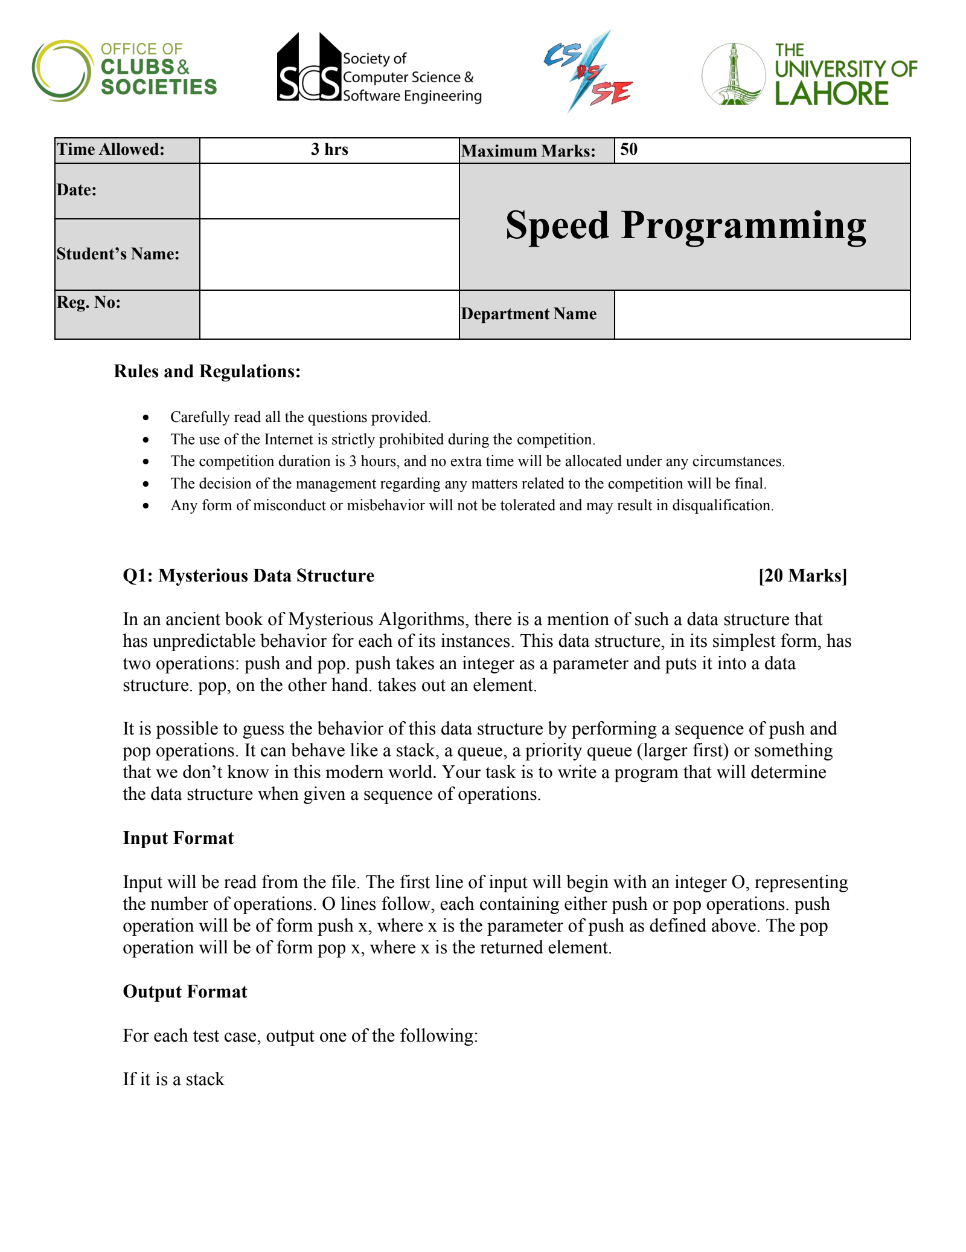

**Page 2 of 6**

LIFO

If it is queue

FIFO

If it is a priority queue

PQ

If it can be more than one of the above

NOT SURE

If it is none of the above

IMPOSSIBLE

Sample Input 1

6

push 1

push 2

push 3

pop 3

pop 2

pop 1

Sample Output 1

NOT SURE

Sample Input 2

2

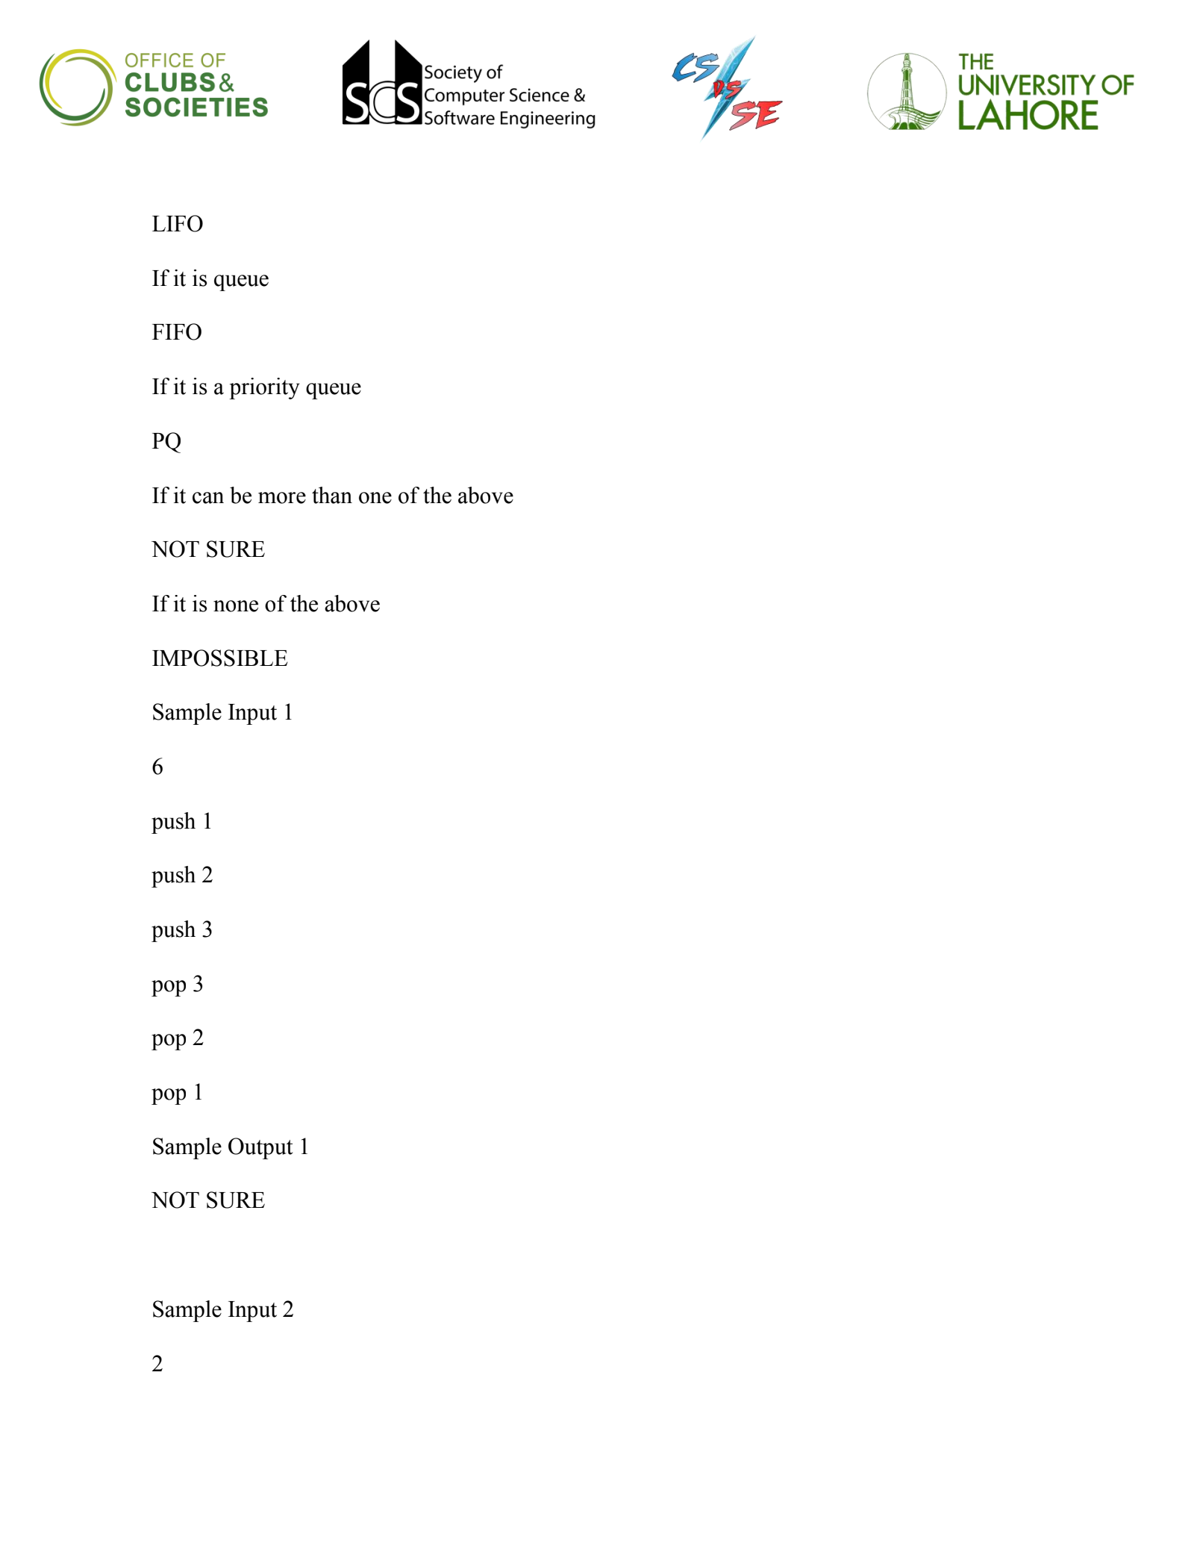

**Page 3 of 6**

push

pop 2

Sample Output 2

IMPOSSIBLE

Sample Input 3

7

push 2

push 5

push 1

push 3

pop 5

push 4

pop 4

Sample Output 3

PQ

Input file reading Instructions:

The input is read from a file. The filename/path of the file is passed to your program as the first

command-line argument. There is no fixed name for the input file. Do not hardcode the input

file name.

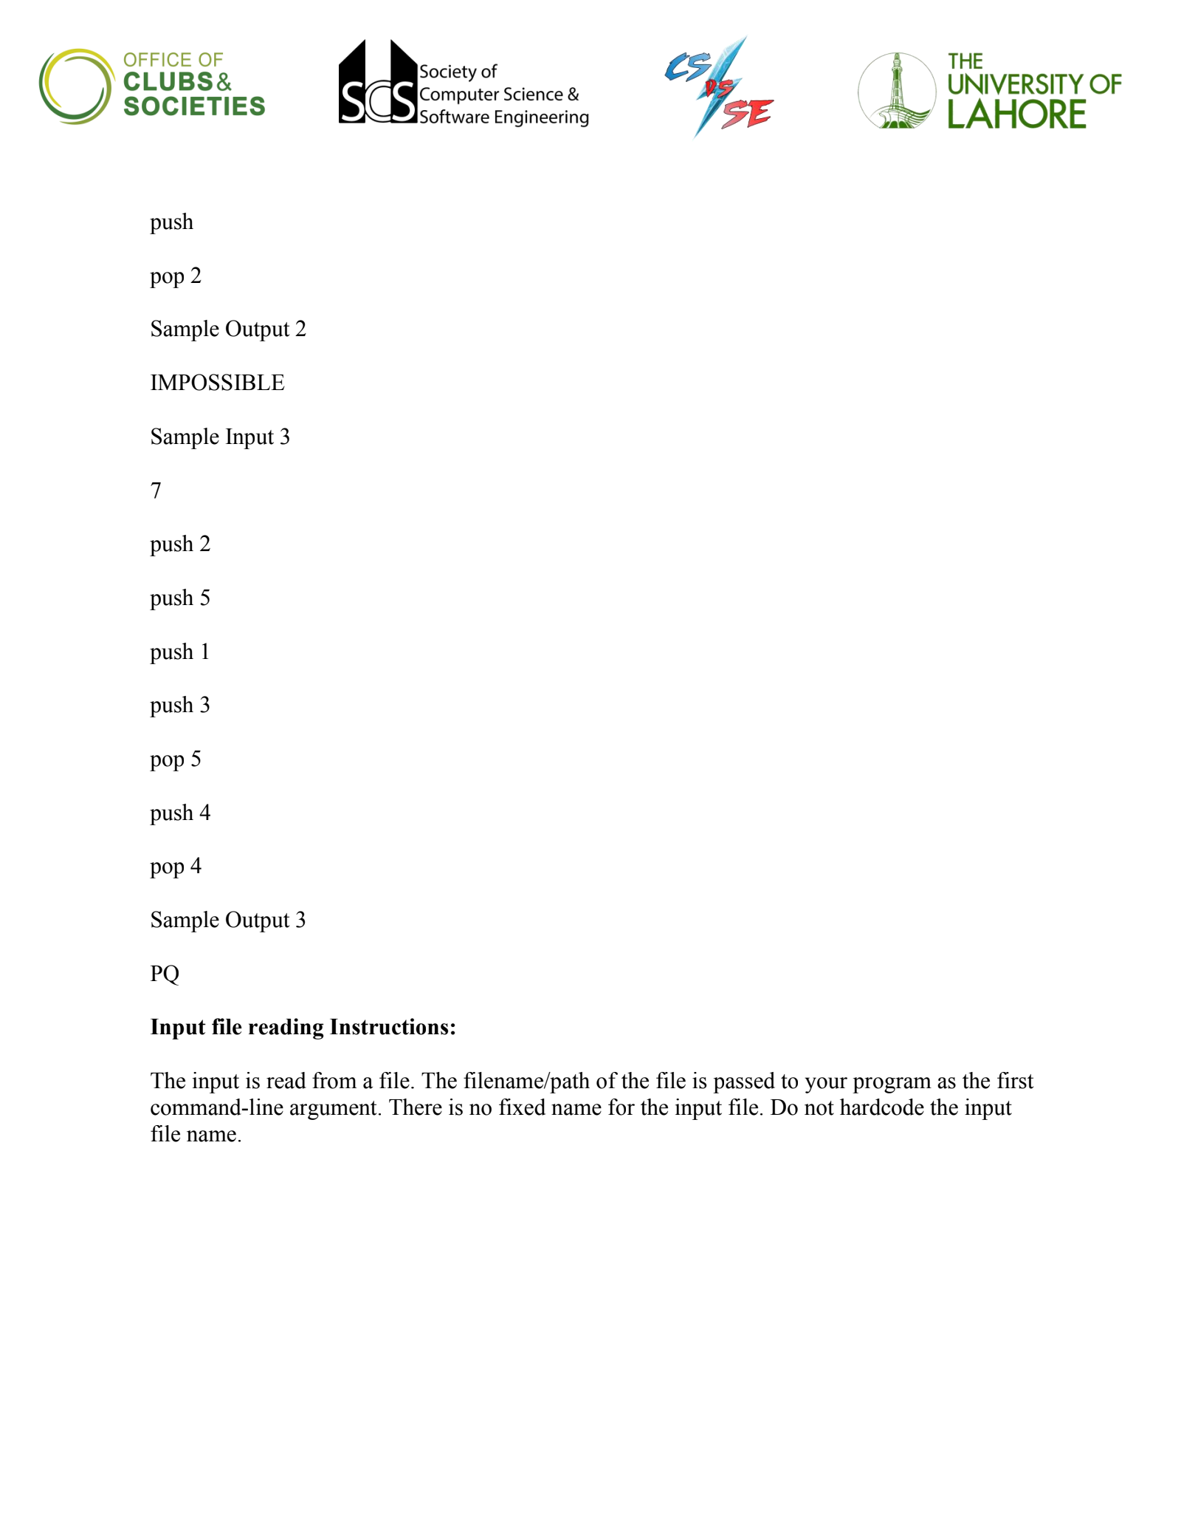

**Page 4 of 6**

Q2: Text Encode

Problem Statement [20 Marks]

The year is 2035, humans have finally found sentient existence in space on a far off planet and

the species existing there seems to be peaceful and as much as in search of us as we were in search

of them.

Now after finally finding them, the one problem that remains is communicating with them.

Linguists from both civilizations cross their heads, try to research other civilizations' words,

letters and come up with some solutions.

After days of brainstorming, they come across a draft which they think will at least break the ice

between the two civilizations.

The aliens come up with this bizarre program after studying English letters and ask humans to

code them in the language of their choice to be able to run on their earthly computers.

There’s a 6x5 matrix of all the capital letters, and the program should mention the instructions to

type the word. For each word, the cursor always starts with the starting 0,0 position which is A.

Whenever one goes down they print ‘d’, ‘u’ for up and ‘l’ (small L), ‘r’ for left and right

respectively.

When cursor is exactly at the letter you need to be, program prints ‘#’.

Since this program needs to print instructions of big words, it has to be very fast in execution.

ABCDE

FGHIJ

KLMNO

PQRST

UVWXY

Z

Like for example, to print ‘UP’ the instructions would be ‘dddd#u#’.

At the start the cursor will be at A position, we will need to do the “d” operation 4 times to come

down to 5th row, we will be at position “U” then where we need to be, so we print “#”, then to

go to “P”, we need to go up again from that position so we print “u” and then we are at “P” so we

just print “#”.

The aliens don’t need space to separate words or punctuation characters for now to get the gist of

the language, you can print instructions of words only ignoring the space between them.

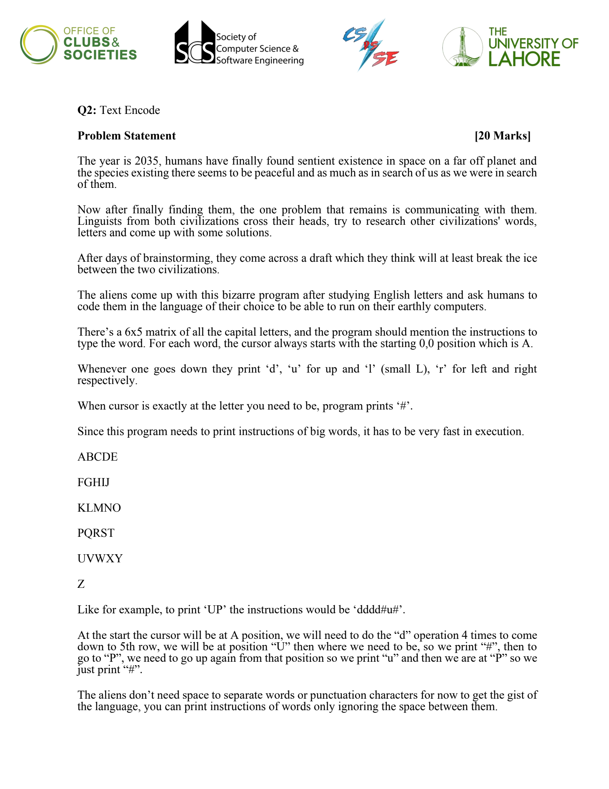

**Page 5 of 6**

Now, to make the encodings consistent for each word, we have set up some rules that:

We will ALWAYS do the vertical operation first. Like if we want to go from A to G we will

always do the “d” operation first & then the “r” operation.

After we are in our relevant row, then we will perform the “l” or “r” operation.

The program has to be efficient, we want to reach our appropriate letter in the shortest way

possible.

Write a program which takes a word as input and outputs the instructions to print it.

Input

The input will be a sentence consisting of words (in all capital letters) separated by spaces. The

input might have non alphabetical characters which need to be ignored.

If n is the total number of characters in the input sentence,

1 n 5000

Output

Output will be the print instructions of each word.

Example

Test Case 1:

Input: UP

Output: dddd#u#

Test Case 2:

Input: UP YOU GO

Output: dddd#u#ddddrrrr#uu#ddllll#dr#drrr#

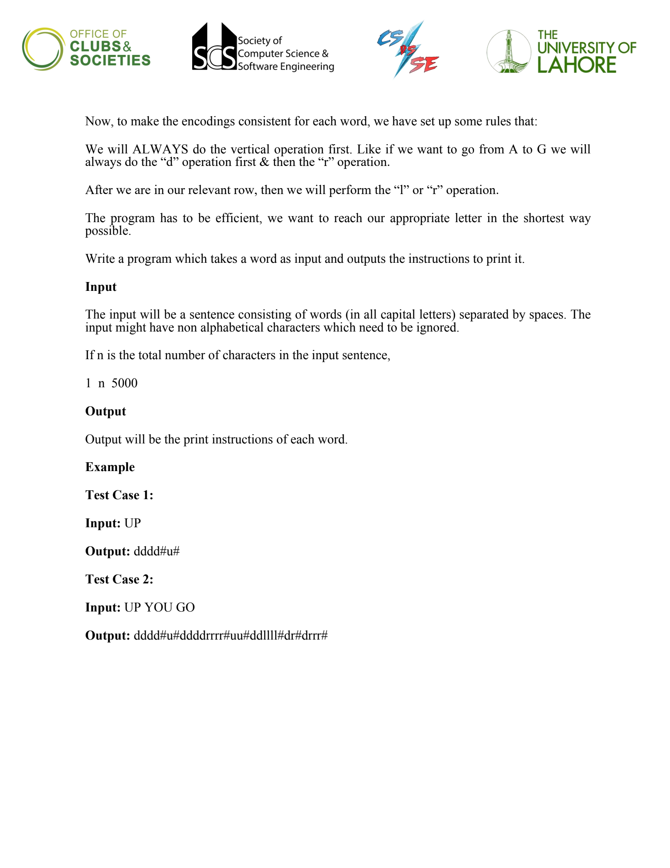

**Page 6 of 6**

Q3: [10 Marks]

Problem Statement

A word is a Palindrome if it is spelled same backward as forward. Examples include madam,

Racecar. Given a string, determine if it is a palindrome or not.

Input

The innput will be read from a file. The file will have a single word. Each character in the word

will be an alphabet.

Output

Output TRUE if the word is a palindrome. FALSE otherwise.

BEST OF LUCK!

---

---

---

---

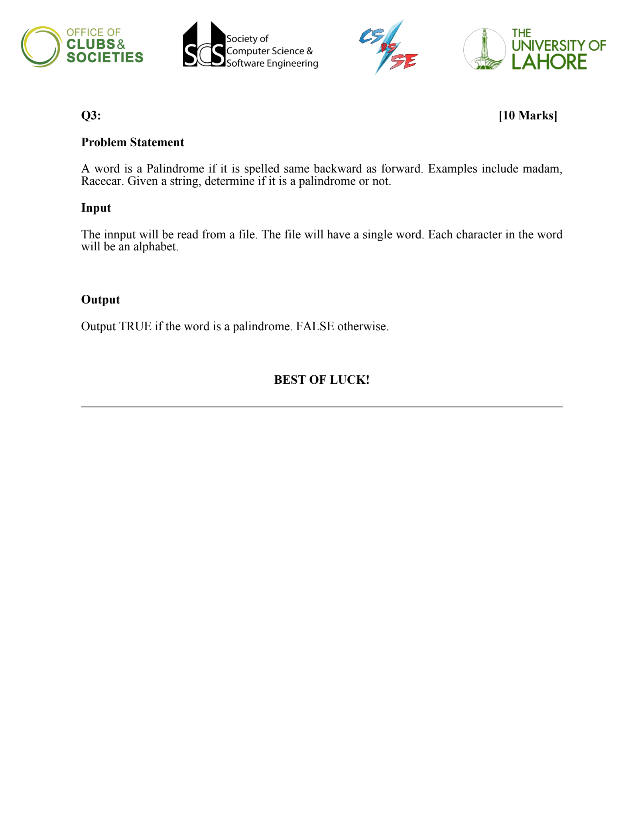

Speed Programming-CS VS SE.pdf

Page 1 of 6

q